

**Invites you to…**

**‘Step in to the NHS’**

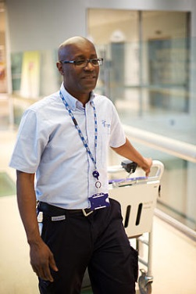



**Careers fair**

**18th June**

**Opportunities**

**Careers**



**10-3pm**

**Work Experience**

**Apprenticeships**

**The Brighton Centre**

**The National Health Service offers a HUGE range of exciting opportunities for people who are passionate about making a difference.**

**With more than 350 different careers in the NHS, there is a job for you no matter what your interests, skills or qualifications!**

www.sussexcommunity.nhs.uk